RDS (Relational Database Service)

1.Open Console page, search for RDS

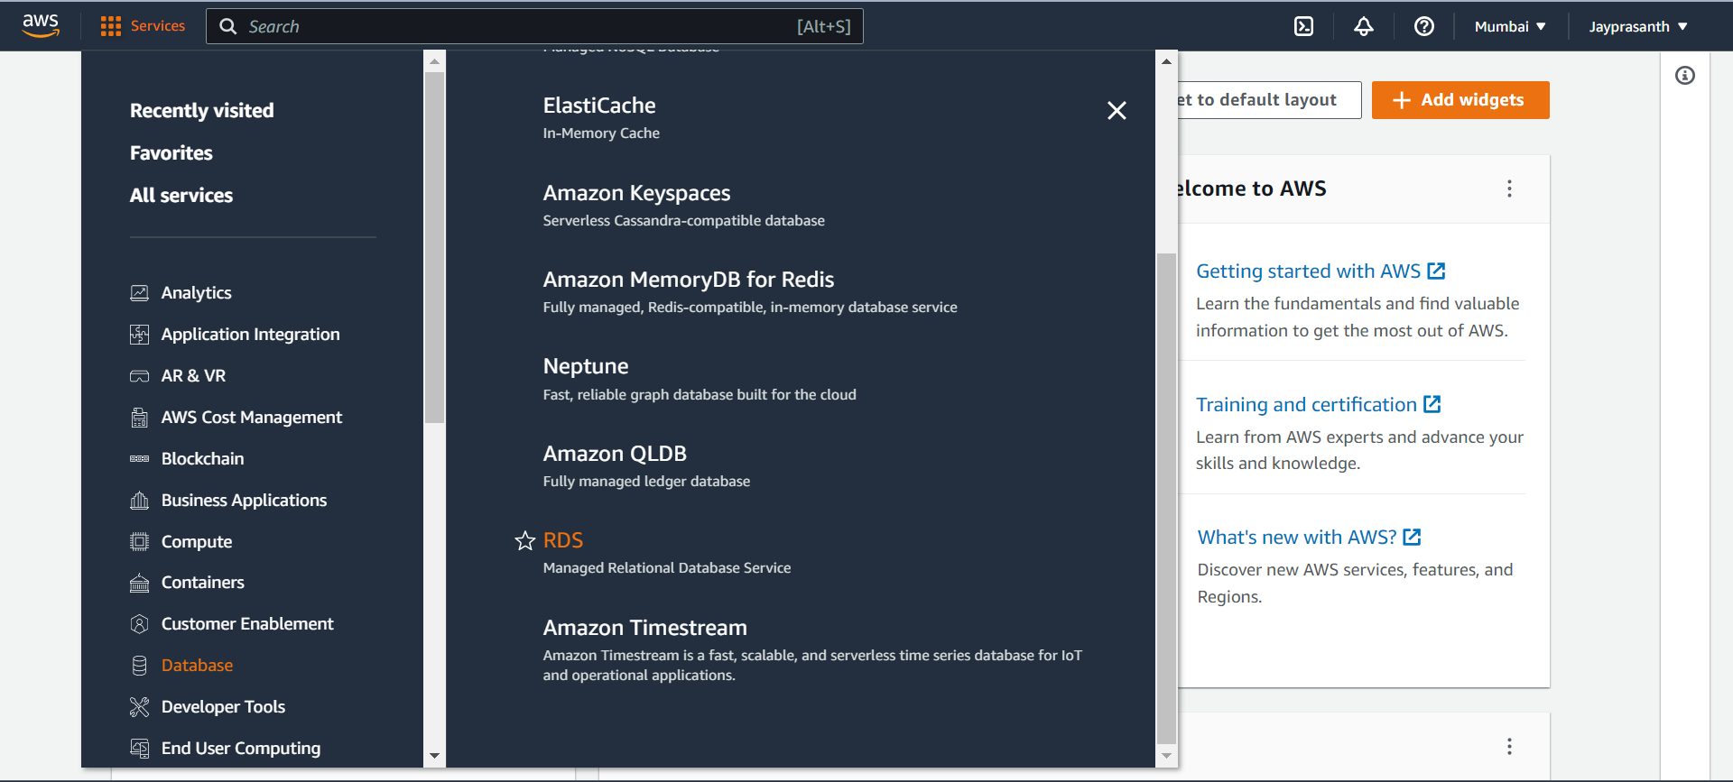

2. This Window Shows the Dashboard of RDS and click create Database

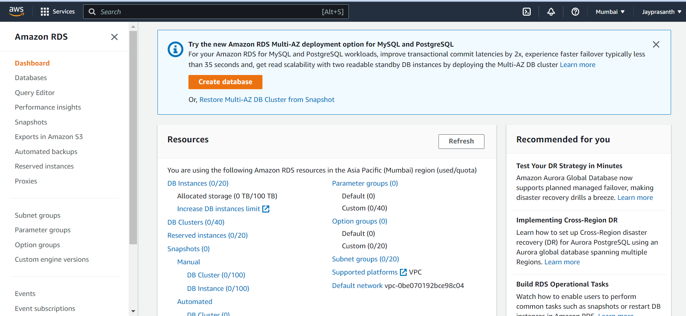

3. after Click, Choose the type Standard or Easy,

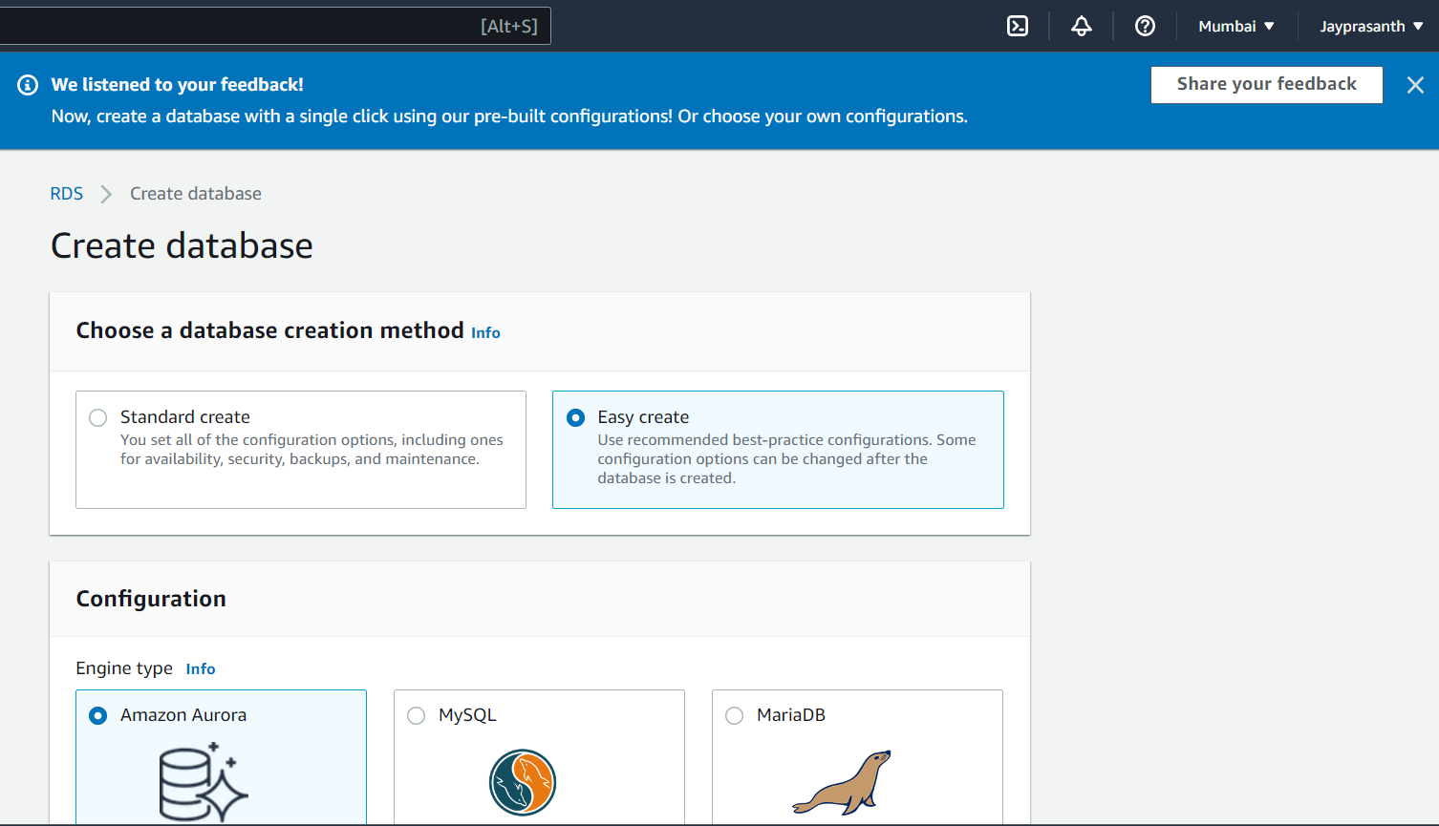

4.AWS allows Third party database to use but not give guarantee for lost our

Data, I select MySQL, size also in free tier

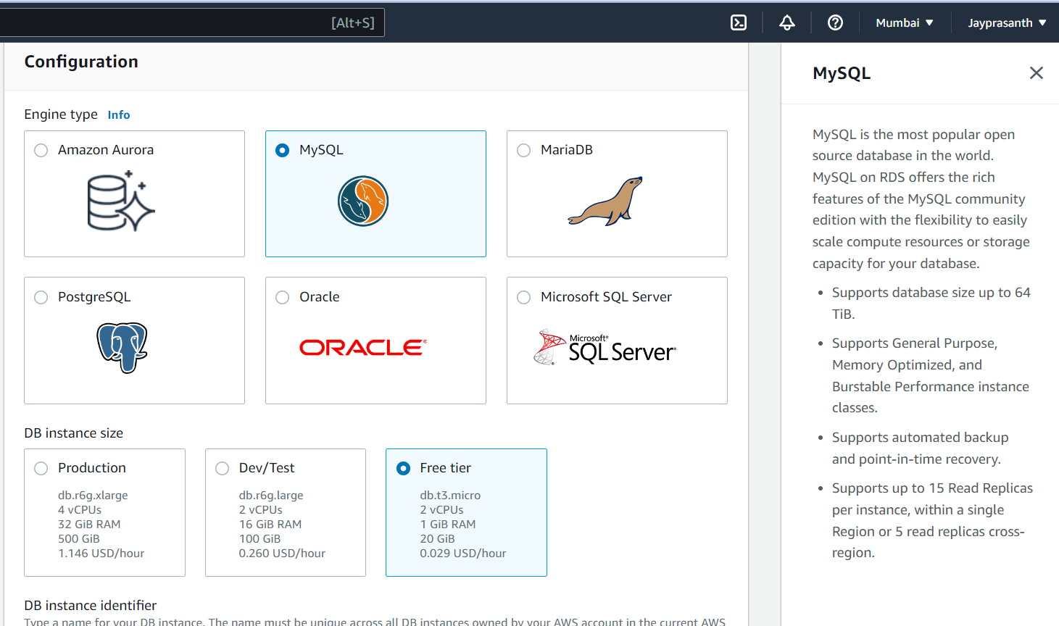

5.in this name of the database, default it as admin in master username and you auto generate password click the check box of auto generate and then click create database

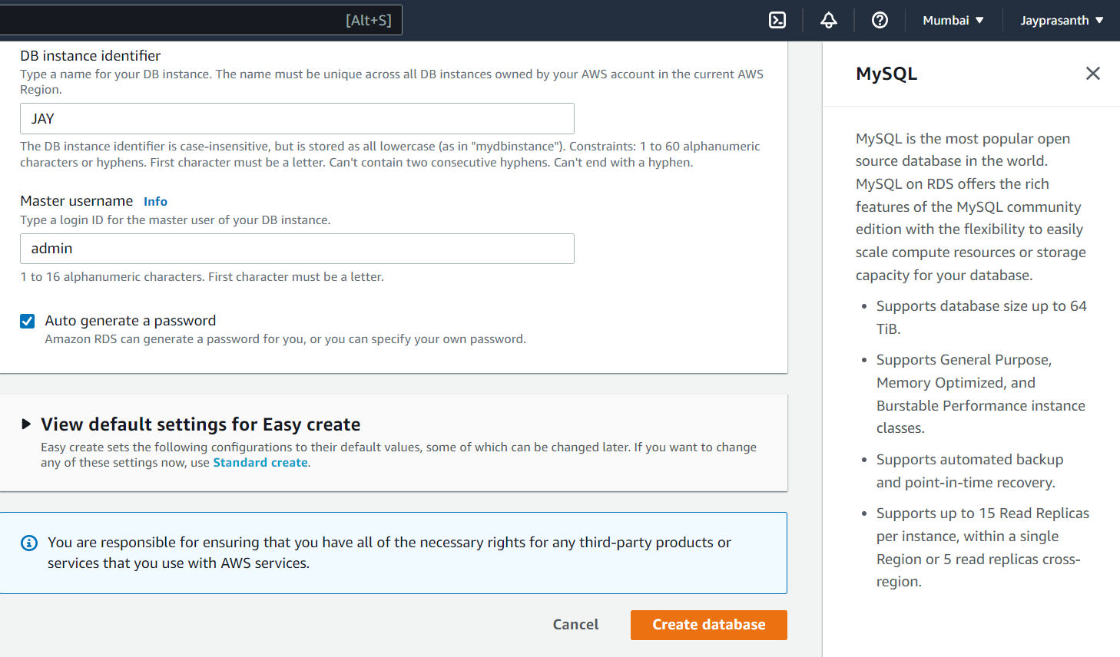

6.after creating, this window shows the created of database

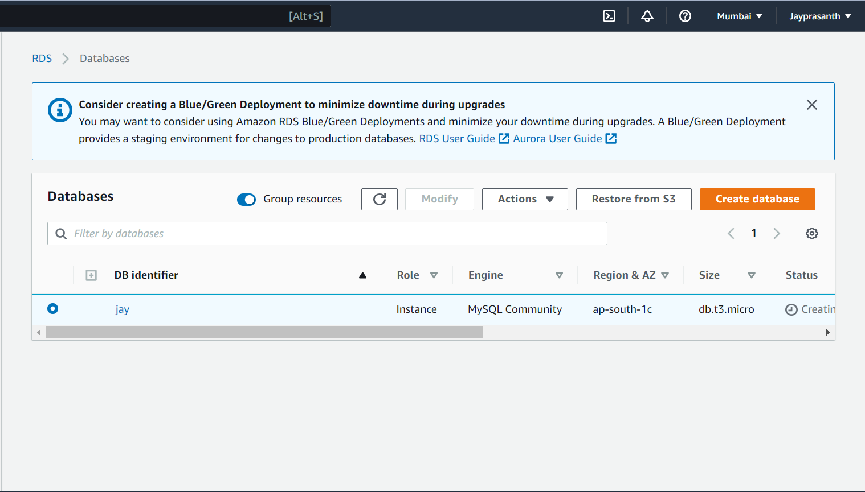

7. to delete the database, Go to Actions --> click Delete

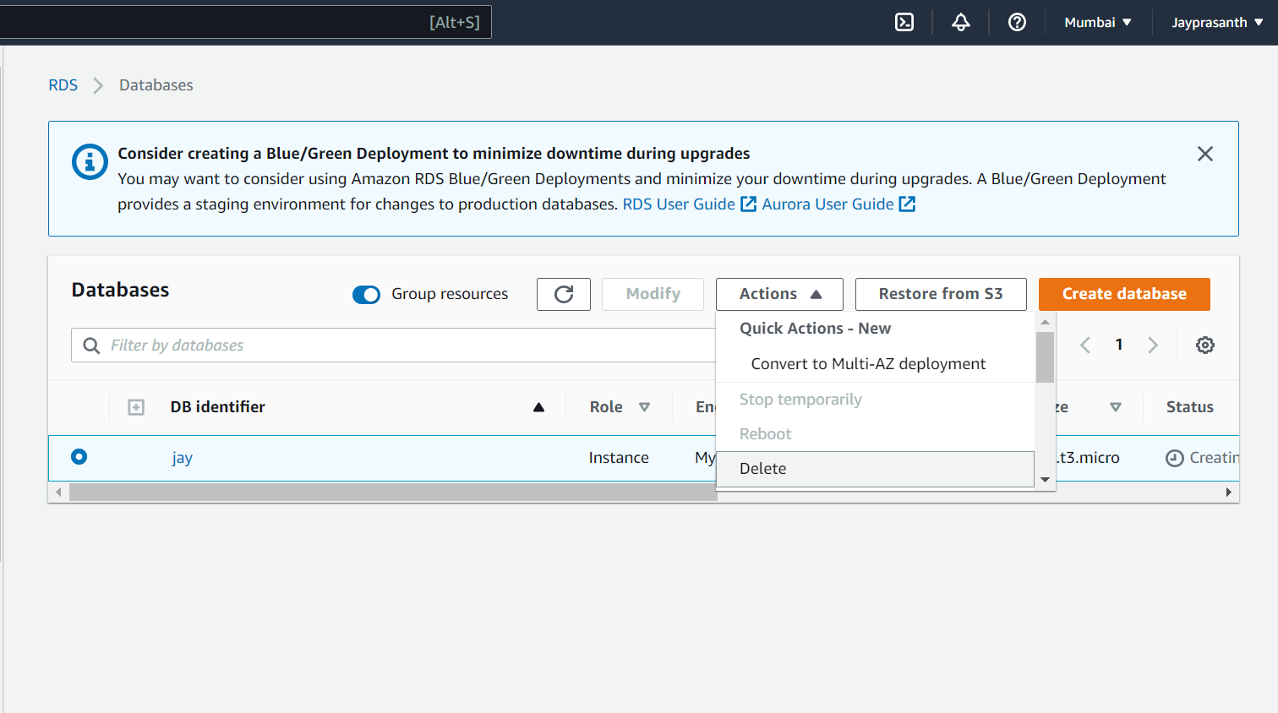

8. Type delete and then click delete

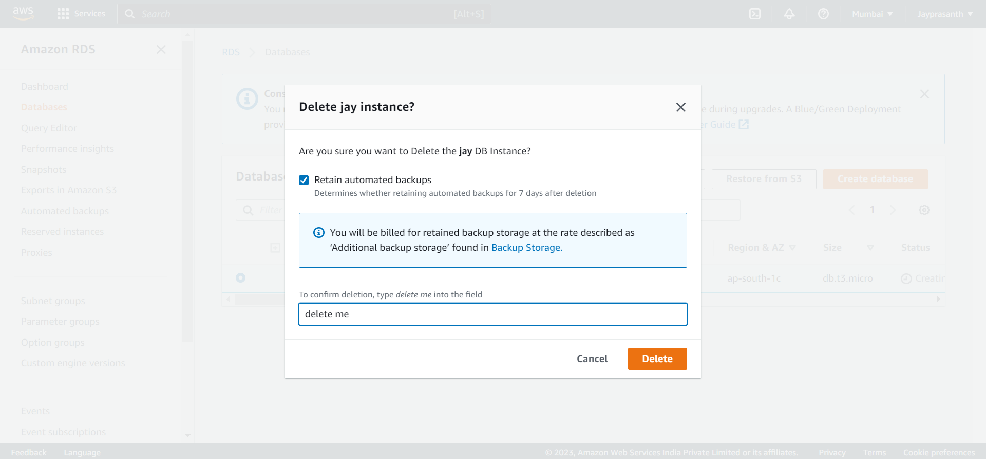

9. This window shows deleted database

